import numpy as np import pandas as pd

import seaborn as sns

# load dataset

df=pd.read_csv("/content/Mall_Customers.csv")

df.head()



|  |  |  |  |  |  |  |  |  |
| --- | --- | --- | --- | --- | --- | --- | --- | --- |
| **CustomerID** | **Gender** | **Age** | **Annual** | **Income** | **(k$)** | **Spending** | **Score** | **(1-100)** |
| **0** 1 | Male | 19 |  |  | 15 |  |  | 39 |
| **1** 2 | Male | 21 |  |  | 15 |  |  | 81 |
| **2** 3 | Female | 20 |  |  | 16 |  |  | 6 |
| **3** 4 | Female | 23 |  |  | 16 |  |  | 77 |
| **4** 5 | Female | 31 |  |  | 17 |  |  | 40 |

# chech missing values

df.isna().sum()

|  |  |  |
| --- | --- | --- |
| CustomerID |  | 0 |
| Gender |  | 0 |
| Age |  | 0 |
| Annual Income | (k$) | 0 |

Spending Score (1-100) 0

dtype: int64

df.isna().sum().sum() 0

# check catogrical values

|  |  |  |  |  |  |  |  |  |
| --- | --- | --- | --- | --- | --- | --- | --- | --- |
|  | **CustomerID** | **Age** | **Annual** | **Income** | **(k$)** | **Spending** | **Score** | **(1-100)** |
| **0** | 1 | 19 |  |  | 15 |  |  | 39 |
| **1** | 2 | 21 |  |  | 15 |  |  | 81 |
| **2** | 3 | 20 |  |  | 16 |  |  | 6 |
| **3** | 4 | 23 |  |  | 16 |  |  | 77 |
| **4** | 5 | 31 |  |  | 17 |  |  | 40 |
| **...** | ... | ... |  |  | ... |  |  | ... |
| **195** | 196 | 35 |  |  | 120 |  |  | 79 |
| **196** | 197 | 45 |  |  | 126 |  |  | 28 |
| **197** | 198 | 32 |  |  | 126 |  |  | 74 |
| **198** | 199 | 32 |  |  | 137 |  |  | 18 |
| **199** | 200 | 30 |  |  | 137 |  |  | 83 |

df._get_numeric_data()

df.shape

200 rows × 4 columns

(200, 5)

# univariant analysis

sns.barplot(df.Age)

/usr/local/lib/python3.7/dist-packages/seaborn/_decorators.py:43: FutureWarning: Pas FutureWarning

<matplotlib.axes._subplots.AxesSubplot at 0x7f916e84a490>

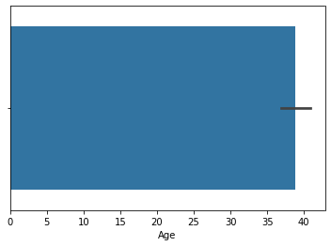

sns.jointplot(df.Age)

<seaborn.axisgrid.JointGrid at 0x7f916dddf250>

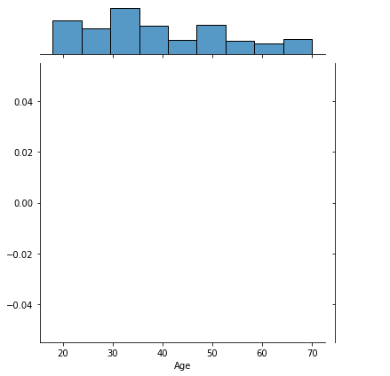

**bivariant analysis**

sns.barplot(df.Age,df.Gender)

/usr/local/lib/python3.7/dist-packages/seaborn/_decorators.py:43: FutureWarning: Pas FutureWarning

<matplotlib.axes._subplots.AxesSubplot at 0x7f916b4737d0>

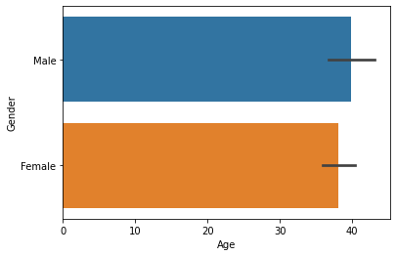

sns.jointplot(df.Age,df.Gender)

/usr/local/lib/python3.7/dist-packages/seaborn/_decorators.py:43: FutureWarning: Pas FutureWarning

<seaborn.axisgrid.JointGrid at 0x7f916b487810>

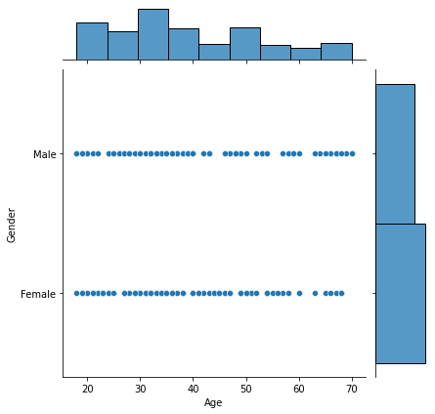

**multi varient analysis**

sns.pairplot(df)

<seaborn.axisgrid.PairGrid at 0x7f916b469750>

# statistics values

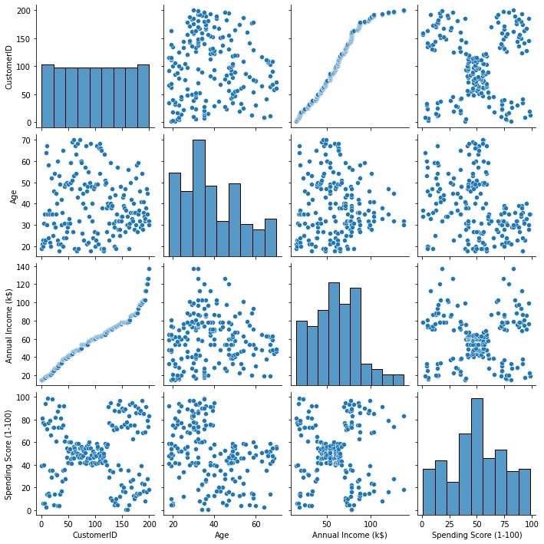

df.info()

<class 'pandas.core.frame.DataFrame'> RangeIndex: 200 entries, 0 to 199

Data columns (total 5 columns):

# Column Non-Null Count Dtype

|  |  |  |  |  |  |  |  |
| --- | --- | --- | --- | --- | --- | --- | --- |
| 0 |  | CustomerID |  | 200 | non-null |  | int64 |
| 1 |  | Gender |  | 200 | non-null |  | object |
| 2 |  | Age |  | 200 | non-null |  | int64 |
| 3 |  | Annual Income | (k$) | 200 | non-null |  | int64 |
| 4 | Spending Score (1-100) | | | 200 | non-null | int64 | |

dtypes: int64(4), object(1) memory usage: 7.9+ KB

# scale the data

from sklearn.preprocessing import MinMaxScaler scalar=MinMaxScaler()

df_new1=df.iloc[:, :-1]

df_new1



|  |  |  |  |  |  |  |
| --- | --- | --- | --- | --- | --- | --- |
|  | **CustomerID** | **Gender** | **Age** | **Annual** | **Income** | **(k$)** |
| **0** | 1 | Male | 19 |  |  | 15 |
| **1** | 2 | Male | 21 |  |  | 15 |
| **2** | 3 | Female | 20 |  |  | 16 |
| **3** | 4 | Female | 23 |  |  | 16 |
| **4** | 5 | Female | 31 |  |  | 17 |
| **...** | ... | ... | ... |  |  | ... |
| **195** | 196 | Female | 35 |  |  | 120 |

**split depandent and indepandent variable**

x=df_new1

**196** 197 Female 45 126

**197** 198 Male 32 126

**198** 199 Male 32 137

**199** 200 Male 30 137

200 rows × 4 columns

y=df['Spending Score (1-100)']

# split test and train data

from sklearn.model_selection import train_test_split

x_train,x_test,y_train,y_test=train_test_split(x,y,test_size=0.2)

# build clustering algorithm model

from sklearn.neighbors import KNeighborsClassifier

knn=KNeighborsClassifier

predict the data

knn.fit(x_train,y_train)

pred=knn.predict(x_test)

# evaluate our model

from sklearn.metrics import accuracy_score,confusion_matrix

accuracy_score(y_test,pred)

confusion_matrix(y_test,pred)